Institute of Systems Science
National University of Singapore

MASTER OF TECHNOLOGY IN
SOFTWARE ENGINEERING

Unit 5 Examination Sample Examination Questions

Subject: Software Project Management

SAMPLE SOLUTIONS

SECTION A

Question 1 [12 Marks]

- To: Business Development Manager
From: Mr X
Review of EPB IPMS Technical Specifications
I have done a quick review of the Intelligent Power Management System (IPMS) technical specifications we have received from the Energy and Power Board (EPB). I have taken a look at the specifications of the seven modules comprising the IPMS.
The technical specifications call for three of the seven modules (the dashboard, analysis / modeling and optimization modules) to make use of Commercial-Off-The-Shelf (COTS) or package software. Because of the use of COTS, I would consider these three modules to have low technology risks. Of the remaining four modules, workflow management and reporting modules are relatively standard IT system requirements.
I would therefore assess that the Unified Data Platform and the Geographic Information System modules would have the highest technology risks.
(2 Marks for identification of the two modules and bonus 2 Marks for ruling out the other five modules)
The development of these two IPMS modules are wrought with risks because:
Unified Data Platform
- This would have to include any required data normalization and cleansing of new and especially existing data. As you know, legacy system databases are frequently filled with inaccurate, incomplete and sometimes even inconsistent data. Cleaning of such data can be complicated, complex and resource consuming.
- Furthermore, the Unified Data Platform would have to integrate with a number of external sources and not all the data sources are clearly identified in the technical specifications. Indeed, the need to integrate with “CCTV images and even MS Offices based documents and information from external web-based sources etc” smacks of unclear requirements and an attempt to include everything including the proverbial “kitchen sink”.
- Finally, the Unified Data Platform has to tag and render searchable all communications, data and information. While this is relatively easy to achieve with structured data, it can be difficult for unstructured data like MS Offices based documents and almost impossible to achieve with media formats like CCTV images.
(Any two of these three – 2 Marks)
Geographic Information System (GIS)
- This would require use to develop the module based on up to five (5) different GIS platforms all of which are TBD (To Be Defined) at this stage. One major technical risk is therefore that the five platforms are all different making our integration a technical nightmare.
- The second major technical risk is that there is a high degree of integration with a number of external sources and again not all the data sources are clearly identified in the technical specifications. The integration is also made more challenging because of the real time nature of the external sources.
- Finally the GIS also has to have an interactive Graphical User-Interface (GUI) that is technically challenging because of the need for advance query capabilities such as network tracing and diagnostics, data visualisation through customisable dashboard and thematic reports with charting capability, slice-and-dice and drill-down analysis by various dimensions e.g. location, time.
(Any two of these three – 2 Marks)
I would further opine that the approach by EPB to implement the GIS in a separate contract that has yet to be called introduces an external dependency that would negatively affect our ability to stay within a fixed schedule. To mitigate this risk, I would suggest that we look into some of the following generic project management risk mitigation approaches to handle such external dependencies:
- Risk avoidance / removal – e.g. try to scope the GIS out of the tender technical specifications
- Risk transfer – e.g shift the responsibility of integration between the IPMS and GIS to the GIS vendor
- Risk minimization – e.g insist that EPB have only a single GIS platform
- Risk localization – e.g quote for the GIS integration based on a best effort time and material basis.
- Risk insurance – e.g bring in a GIS expert; adopt open standards to facilitate interoperability and integration across modules and COTS packages purchased.
(1 Mark for identification of the GIS module and 3 Marks for any three of the above generic project risk management strategies)
As I am extremely uncomfortable with the above challenges, please help highlight our discomfort to EPB during the coming tender clarification briefing.
- Virtualising and hosting the IPMS in the “cloud” would introduce major technical challenges to meet two of the system quality requirements in the IPMS Technical Specifications relating to security and the robustness / reliability of the system.
  - Security is a challenge in the “cloud” because we will have to rely on the provider of the platform as a service to implement, maintain and enforce the security matrix. Anything hosted on the internet rather than in a standalone environment is susceptible to security threats found on the internet.
  - And while “cloud” infrastructure can be inherently robust and reliable, its delivery to the ICC 24 by 7 can be a challenge as it would depend on the redundancy of internet connectivity to the ICC. It is also not advisable to place real time operational systems at the mercy of external infrastructure given that the external infrastructure depends on the same real time operational system i.e. if the power fails so most likely will internet connectivity fail as well. There will then be no way to “boot strap” the recovery since the IPMS itself will then be unreachable in the “cloud”.
(Any one of these two – 2 Marks)
Question 2 [Total: 20 Marks]

The student’s answer should describe an Incremental or Phased Development approach to meet the three delivery milestones. They should mention the objective of each delivery. There would be no need to give a complete work breakdown structure.
(3 Marks)
Activities that should be included to address the other business issues:
# | Issue | Activities
 | In reality, the station manager does not have a clear view of the detailed requirements | - Conduct requirements gathering exercise with station manager and other key users  - Define the requirements clearly in a URS document.  - Conduct review of URS with station manager, and obtain sign-off.
 | He emphasised to the IT manager that the user interface must be acceptable to the radio station staff | - Create user interface prototypes  - Review prototypes with the radio station staff
 | Web-site design must be popular with the listeners | - Conduct an exercise with the public to find out their opinions of the current system ie: what do they like, what do they dislike?  - Invite members of the public that expressed their opinion to give feedback on the proposed design for the new web-site.  - After the new web-site goes live, have a short period when opinions of the public are collected, and final changes are made to address major problems and issues.
 | The station manager expressed his concern that the presenters and producers may not fully understand how to use the system. In which case, it that may waste their time unnecessarily | - Provide user training.  - Prepare and issue a user guide to all users.  - Undertake user reviews of training material and user guide.  - Log user activity during the cut-over period, and review logs for errors and deficiencies.
 | He emphasised that there must not be any reduction in business efficiency during the introduction of the new system. | - Undertake thorough testing to minimise the risk of system crashes.  - Provide dedicated support to the users when the system is in use during the cut-over period.
(7 Marks)
Marking Scheme: 0.5 marks for each valid issue and 0.5 marks for each valid activity up to a maximum of 7 marks.

# | Risk Items | Strategies
 | The programmers currently do not have the necessary knowledge or skills | - Send them on training courses.  - Hire one or more contract staff with the necessary skills to act as technical leads.  - Engage a consultant to provide advice to the project, and prepare detailed design instructions to provide specific guidance to the inexperienced programmers.
 | The team size is quite small, and the project may be under-resourced, given the tight schedule. | - Hire one or more contract staff with the necessary skills.  - Consider outsourcing the Java programming portion of the project to a vendor. The IT department staff could focus on requirements (including GUI), integration with new web-site, user guide preparation, user training, and acceptance testing.
 | The schedule is fixed and ambitious, and difficult to negotiate on particularly for the first release. | - Produce a detailed plan to verify the feasibility of the schedule.  - Move as many activities as possible out of the first phase of the project ie: up to the first release, such as delaying formalising the design spec until a later phase.  - Negotiate on the dates of the second and third releases given that there does not appear to be a strong commercial reason for the dates. Use the detailed plan to demonstrate to the station manager that the schedule is infeasible.
 | The IT manager may be over committing himself by taking on both the project manager and designer/architect role. It may create a bottle-neck for the project. | - Engage a consultant to perform the designer/architect role.  - Assign an experienced project manager from the IT department to perform the project management role. Given the importance of this project, it would be worth spending more of the internal resources of the department.
 | The installation of the hardware and software may appears to be very late – 6 weeks into a phase that must complete in 3 months. This may delay the development work. | - Consider loaning the necessary hardware and using alternative software temporarily until the equipment arrives.  - Source for a vendor that can deliver earlier.
(10 Marks)
Marking Scheme: 1 mark for each valid risk and 1 mark for each valid risk resolution strategy up to a maximum of 10 marks.
c. (8 Marks)
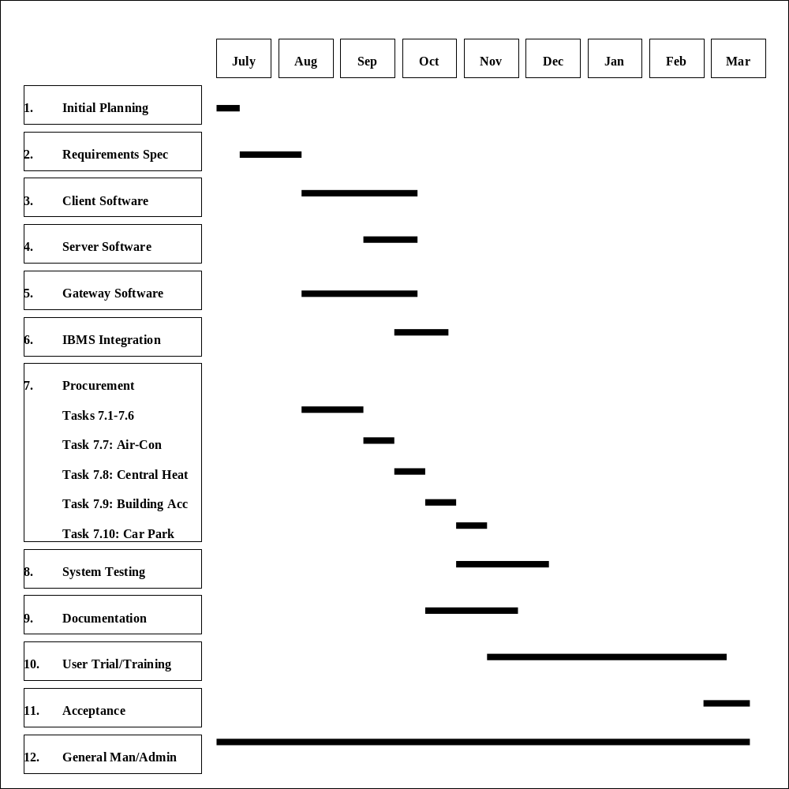
Marking scheme:

- The WBS should include:

Planning, including: (1.5 Marks)
- project planning,
- test planning,
- trial/training planning.
Requirements (1 Mark)
UI Design (0.5 Marks)
DB Design (0.5 Marks)
Software Design (0.5 Marks)
Contractual Negotiations etc for Infrastructure Systems (1 Mark)
Acceptance of Infrastructure Systems (1 Marks)
Integration Testing for IBMS (0.5 Marks)
System Testing (0.5 Marks)
User Trial (inc support and corrective action) (1 Mark)
Training (inc preparation) (0.5 Marks)
Documentation (inc design/planning of docs) (0.5 Marks)
Internal reviews (1 Mark)
External reviews (1 Mark)
Final Acceptance (0.5 Marks)
General Management and Admin (0.5 Marks)

- The estimates will be graded as follows:

Adherence to estimating guideline (2 Marks)
Appropriate efforts for activities not covered by guideline:
- Planning (1 Mark)
- Reviews (1 Mark)
- Infrastructure Systems Activities (1 Mark)
- User Trial/Acceptance (1 Mark)
Contingency to handle uncertain vendor prices (2 Marks)
Completeness/correctness of Costing (1 Mark)
Required profit level (1 Mark)

- The schedule will be graded as follows:

Correct precedence (2 Marks)
Appropriate durations for activities (except User Trial) (2 Marks)
Appropriate scheduling/duration for User Trail (1 Mark)
Contingency to handle uncertain vendor delivery dates (1 Mark)
Required delivery date (2 Marks)
SECTION B

Question 3 [Total: 30 Marks]

a. (12 Marks)

Quarter | 3 | 6 | 9 | 12 | 15 |  | 18 |  | 21 |  | 24 |  | 27 |  | 30 |  | 33 |  | 36
1. Implementation Costs
Hardware | 6000
Hardware Installation | 3000
Software/Network | 2000 | 5000 | 3000
Training |  |  |  | 3000
Telecoms | 1000
2. New System Running Costs
Labor |  |  |  | 18000 | 18000 |  | 18000 |  | 18000 |  | 18000 |  | 18000 |  | 18000 |  | 18000 |  | 18000
Accommodation |  |  |  | 9000 | 9000 |  | 9000 |  | 9000 |  | 9000 |  | 9000 |  | 9000 |  | 9000 |  | 9000
Services |  |  |  | 4500 | 4500 |  | 4500 |  | 4500 |  | 4500 |  | 4500 |  | 4500 |  | 4500 |  | 4500
Hardware Mtce |  | 180 | 180 | 180 | 180 |  | 180 |  | 180 |  | 180 |  | 180 |  | 180 |  | 180 |  | 180
Software Mtce |  |  |  | 300 | 300 |  | 300 |  | 300 |  | 300 |  | 300 |  | 300 |  | 300 |  | 300
Telecom Line Mtce/Rental |  | 300 | 300 | 300 | 300 |  | 300 |  | 300 |  | 300 |  | 300 |  | 300 |  | 300 |  | 300
Total Costs | 12000 | 5480 | 3480 | 35280 | 32280 |  | 32280 |  | 32280 |  | 32280 |  | 32280 |  | 32280 |  | 32280 |  | 32280
Benefit
Savings due to reduced inventory |  |  |  |  | 5000 |  | 5000 |  | 10000 |  | 10000 |  | 10000 |  | 10000 |  | 10000 |  | 10000
Savings due to reduced manning |  |  |  |  | 42000 |  | 42000 |  | 42000 |  | 42000 |  | 42000 |  | 42000 |  | 42000 |  | 42000
Total Benefits |  |  |  |  | 47000 |  | 47000 |  | 52000 |  | 52000 |  | 52000 |  | 52000 |  | 52000 |  | 52000
Total Costs -Benefits  (Cashflow) | -12000 | -5480 | -3480 | -35280 |  | 14720 |  | 14720 |  | 19720 |  | 19720 |  | 19720 |  | 19720 |  | 19720 |  | 19720
Accumulated  Costs-benefits | -12000 | -17480 | -20960 | -56240 |  | -41520 |  | -26800 |  | -7080 |  | 12640 |  | 32360 |  | 52080 |  | 71800 |  | 91520

b. (6 Marks)

The benefits-costs of the new system become positive in quarter 12-15,

The cumulative costs-benefits of the new system exceed $S70,000 in quarter 30-33

c. (12 Marks)

EXECUTIVE SUMMARY FOR THE PROPOSED QUARTZ STORE WAREHOUSE INVENTORY SYSTEM

Terms Of Reference

One of the major sources of cost for the QUARTZ furniture store is the storage of furniture in the two warehouses owned by the group. Currently the administration and ordering of furniture is carried out manually. It has been proposed to replace the current system with a PC-based network which would be sited at both the warehouses and the main furniture stall. This paper describes the evaluation of the proposed system .

Recommendation:

To implement a PC-based network . The major reasons for this were;
• The total benefits -costs do not slip below the stated limit of $S60,000
• The cashflow becomes positive in quarter 12-15
• The cumulative costs - benefits over the initial three years following project inception is $S91520
• The development of IT user skills within Quartz
• The implementation of the system would bring improved management monitoring and control

The Cash flow over each quarter is shown below:

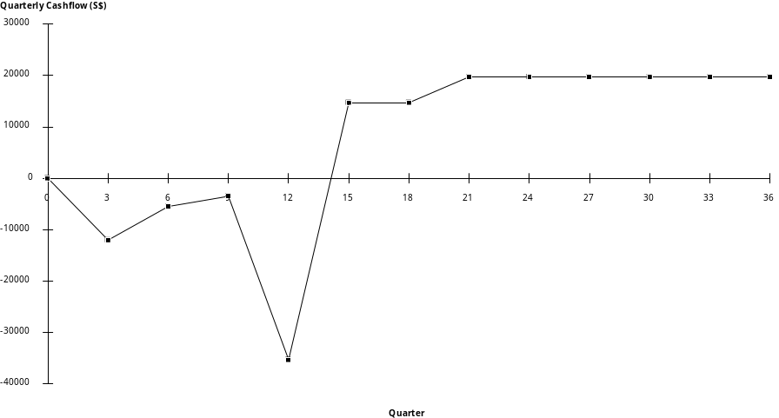
The Accumulated benefits-costs are summarized in the below figure:

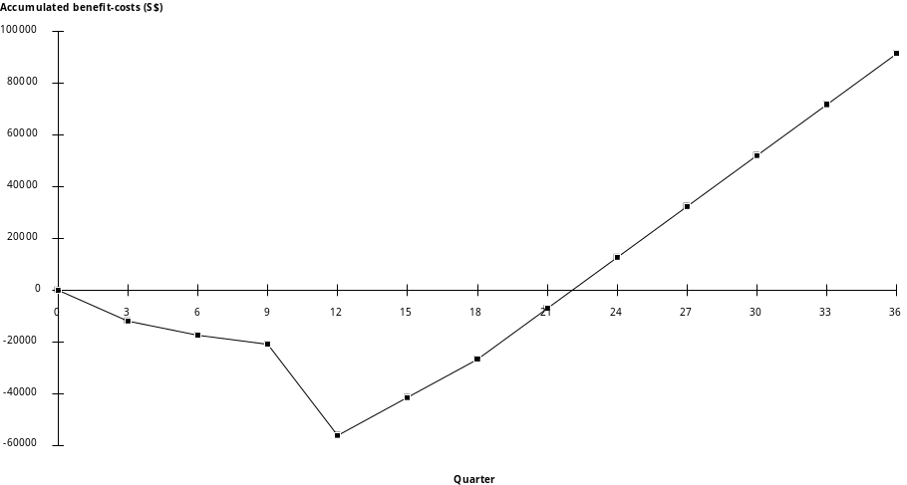

SECTION C

Question 4 [30 Marks]

a.

Data Functions

Internal Logical Files |  |  | Elements of complexity
Type | Reference | Description | DET | RET | Complexity
ILF | - | Bungalow Details  - Street number  - Bungalow number  - Number of Bedrooms  - Lease Status (available, under offer,....)  - Standard monthly lease payments | 5 | 1 | L
ILF | - | Application Details  - Lease Application reference number  - Name.  - Sex.  - Current address.  - Age.  - Birth date.  - Occupation.  - Current salary.  - Financial guarantor.  - Desired Property : Bungalow No.  - Desired Property : Street No.  - Lease commencement date  - Desired period of lease.  - Proposed method of payment  - Bank account number  - Accept/reject decision  - Monthly payment  - Selected payment method | 18 | 3  (PersFin.Dec) | L

External Interface Files |  |  | Elements of complexity
Type | Reference | Description | DET | RET | Complexity
EIF | - | Branch office/Main office details  - Branch office Sales Manager Name  - Branch office Address | 2 | 1 | L
Transactional Functions

Inputs |  |  | Elements of complexity
Type | Reference | Description | DET | FTR | Complexity
EI | Screen 1 | Input applicant details  - Lease Application reference number  - Name.  - Sex.  - Current address.  - Age.  - Birth date.  - Occupation.  - Current salary.  - Financial guarantor.  - Desired Property : Bungalow No.  - Desired Property : Street No.  - Lease commencement date  - Desired period of lease.  - Proposed method of payment  - Bank account number  - F5 Key  - Error Message | 17 | 1 | A
EI | Screen 2 | Input decision  - Accept/reject  - Selected monthly payment  - Selected payment method  - Error Message  - F5 Key | 5 | 2 | A
EI | Screen 4 | Input New Bungalows  - Street number  - Bungalow Number  - Number of Bedrooms  - Standard monthly lease payments  - Error message  - F5 Key | 6 | 1 | L
EI | Screen 5 | Update Bungalow details  - Street number  - Bungalow Number  - Lease status  - Error message  - F5 Key | 5 | 1 | L

Enquiries |  |  | Elements of complexity
Type | Reference | Description | DET | FTR | Complexity
EQ | Screen 2 | Input Side  - Lease Application reference number  - F5 Key | 2 | 1 | L
 |  | Output side  - Name.  - Sex.  - Current address.  - Age.  - Birth date.  - Occupation.  - Current salary.  - Financial guarantor.  - Desired Property : Bungalow No.  - Desired Property : Street No.  - Lease commencement date  - Desired period of lease.  - Proposed method of payment  - Bank account number  - Standard monthly lease payment  - Error Message | 16 | 2 | A
EQ | Screen 3 | Input Side  - Street number  - F5 Key | 2 | 1 | L
 |  | Output side  - Bungalow number.  - Number of Bedrooms.  - Standard monthly lease payment  - Error Message | 4 | 1 | L
EQ | Screen 5 | Input Side  - Street number  - Bungalow number  - F5 Key | 2 | 1 | L
 |  | Output side  - Bungalow Number.  - Number of Bedrooms.  - Standard monthly lease payment  - Error Message | 4 | 1 | L

Output |  |  | Elements of complexity
Type | Reference | Description | DET | FTR | Complexity
EO | Computer generated  Letter | Rejection Letter  - Applicant Name  - Applicant Address  - Application Reference Number  - Accept/Reject decision  - Branch/Head office Sales Manager Name | 5 | 2 | L
EO | Computer generated  Letter | Offer Letter  - Applicant Name  - Applicant Address  - Application Reference Number  - Accept/Reject decision  - Bungalow Number  - Street Number  - Lease Commencement Date  - Lease Period  - Monthly Lease Payment  - Branch/Head office Sales Manager Name  - Branch/Head office address | 11 | 2 | A

Unadjusted Function Point Count Summary

ITEM | LOW | AVERAGE | HIGH | TOTAL
External Input | 2x3 = | 2x4 = | x6 = | 14
External Output | 1x4 = | 1x5 = | x7 = | 9
Internal File | 2x7 = | x10 = | x15 = | 14
Interface file | 1x5 = | x7 = | x10 = | 5
External Inquiry | 2x3 = | 1x4 = | x6 = | 10
 |  | Unadjusted | Function Points | = 52

[20 Marks]
b.

Calculate Value Adjustment Factor

CHARACTERISTIC | DI
Data Communications | 4
Distributed Functions | 0
Performance | 4
Heavily Used configuration | 3
Transaction Rate | 0
On-line Data Entry | 5
End User efficiency | 1
On-line Update | 3
Complex Processing | 0
Re-usability | 1
Installation Ease | 0
Operational Ease | 1
Multiple Sites | 1
Facilitate Change | 0
Total Degree of Influence | 23

Adjustment Factor = 0.65 + (0.01 x Total Degree of Influence) = 0.88

Adjusted FPC = Unadjusted FPC* Adjustment Factor = 52*0.88 = 45.8

[10 Marks]
SECTION D

Question 5 [25 Marks]

The Memo should include the following:

- See Figure 1.

The revised costs for the project are as follows

Labour cost expended to date = 99 * 500: 49500
Labour costs to be expended to end of project = (210 + 8)*500: 109000
(using current budget)
Total labour costs: 158500

Hardware cost: 50000
Software cost: 37500

Contingency (reduced by 6000): 14000

Profit 40000

TOTAL 300000

(8 Marks)

Possible options for completion of project:

There are two possible solutions to the problem of completing the project:
- Continue with the in-house development, as outlined by SA1 in the progress meeting.
- Purchase and Install the “QuickLook” Package.
A brief description of each, and the costs and plans , follows:

- The in-house development option

This solution would involve continuing with the original solution, but working the original design and putting more effort into CUT of the online quality surveillance module. The changes to the WBS would be as follows:
- A new task 3.3: “Revise design” would be generated with a budget of 4 days for the SA1.
- Task 4.1 would be completed , but with the extra 8 days allocated to it as indicated in the progress report for this task; 4 days to the PM and 4 days to PR1.
- Task 5.1 would have an extra 10 days allocated to it; 5 days to the PR1 and 5 days to the PR3.
Figure 2 shows the PERT chart for this option and figure 3 shows the Gantt chart.

The costs for this option are as follows:

Labour cost expended to date = 99 * 500: 49500
Labour costs expended to end of project =(210 +8+4+10)*500: 116000
(using projected & current budget)
Total labour costs: 165500

Hardware cost: 50000
Software cost: 37500

Contingency(further reduction of $7000): 7000

Profit: 40000

TOTAL 300000

However there is a hidden cost here of missing deadlines. Referring to the Gantt chart it appears the system will only be delivered by 7/11/97. The original agreed delivery date was 6/27/97. The difference is 14 calendar days. From the penalty clause in the contract:

- “In the event of late delivery of the system or services, WBH Pte Ltd agrees to pay Everest Systems plc 0.1% of the total contract value by way of recompense for each calendar day past the agreed delivery date. This will continue for ninety days, after which the client may choose to take further sanctions against the contractor, including legal proceedings, without prejudicing these damages.”

It appears there may be and additional cost of 14*S$300000 *0.1% = $S4200, thus reducing contingency to S$2800

ii. The “Buy-in” option

This solution would involve purchasing the QuickLook package and installing and integrating it with the other subsystem. The plan would involve removing task 5.1: CUT Online quality surveillance system and writing off the effort on tasks 3.1 and 4.1, and not expending extra effort on task 4.1.
Two new tasks would be generated:
- Task 3.3 : Procure and install QuickLook.
- Task 3.4 : Familiarise with QuickLook.
The direct costs and budgets associated with each would be as follows:
Task 3.3 : Procure and install QuickLook: A direct cost of $S30000 and an effort budget of 1 day for the SA1 to supervise the installation procedure.
Task 3.4 : Familiarise with Quick Look package: Here there would be an effort budget of 3 days for the SA1 to understand how QuickLook operates. This would minimise dependence on XpreSS.
Thus the increase in effort would be 4 days, but this would be countered by money saved by removing task 5.1 = 35 days =$S17500.

Figure 4 shows the new dependency chart and Figure 5 shows the revised Gantt chart.

The new costs are as follows:

Labour cost expended to date = 99 * 500: 49500
Labour costs expended to end of project = (210 + 4-35)*500 89500
(using projected & current budget)
Total labour costs: 139000

Hardware cost 50000
Software cost: 37500

Cost of QUICKLOOK procurement & installation: 30000

Contingency(further reduction of $10500): 3500

Profit: 40000

TOTAL 300000

iii. Risk Analysis for Both options

Risks for Option (i); “In-house” | Risks for Option (ii): “Buy-in”
- Late delivery of Software may involve Everest invoking the penalty clauses , and reducing still further the contingency budget.  - Also missing Deadlines will impact on customer confidence  - Up to this point in time WBH have been unable to construct a real-time performing on-line quality surveillance system. Just spending more money may not necessarily make it work.  - The Gantt chart shows that the SA2 and PR2 are waiting for the SA1 & PR1 & PR3 to complete design and coding (which will take at least 3 weeks). During this period SA2 and PR2 are idle. It is possible they could be assigned to another project and hence lost to the NPLQMS project | - The “QuickLook” system appears to be the more expensive option  - Buying the “QuickLook” package may de-motivate the Sa1 who may either resist the implementation of the package, or simply leave the project.  - The “QuickLook” package may not meet requirements  - XpreSS may use this as a commercial lever to secure “follow-on” contracts in this area in opposition to WBH
(9 Marks)

c. Recommendation

I would recommend the option (ii) as:
- Our current technical strategy does not appear to work.
- Buying in an existing, proven package would reduce technical risk.
- It is ultimately the cheaper solution.
- Option (ii) also brings the project back to the original end date of 6/27/97.

Gantt charts and task descriptions are given in the earlier analysis of options
(8 Marks)

Figure 1: GANTT chart showing progress for Quality monitoring system development

 |  | 3/3 | 3/10 | 3/17 | 3/24 | 3/31 | 4/7 | 4/14 | 4/21 | 4/28 | 5/5 | 5/12 | 5/19 | 5/26 | 6/2 | 6/9 | 6/16 | 6/23 | 6/30
Task 1 | Planning
Task 2 | Detailed requirements
Task 3.1 | Design of online quality
Task 3.2 | Design of def an.al/corrn.
Task 4.1 | Prototype on-line quality
Task 4.2 | Prototype def anal/corrn.
Task 5.1 | CUT online quality
Task 5.2 | CUT defect anal/corrn.
Task 6 | Integration
Task 7 | Systems Test
Task 8 | Acceptance Test
Task 9 | Management
Current position of project
Key :
Completed tasks
In progress
Not yet started
The current estimated end date is 4/7/97
Figure 2: PERT Chart for Option (i) - “In-house”
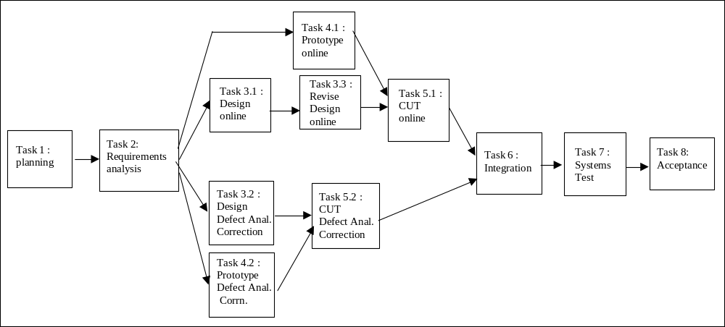

Figure 3: GANTT chart showing Option (i) for Quality monitoring system development

 |  | 3/3 | 3/10 | 3/17 | 3/24 | 3/31 | 4/7 | 4/14 | 4/21 | 4/28 | 5/5 | 5/12 | 5/19 | 5/26 | 6/2 | 6/9 | 6/16 | 6/23 | 6/30 | 7/7
Task 1 | Planning
Task 2 | Detailed requirements
Task 3.1 | Design of online quality
Task 3.2 | Design of def an.al/corrn.
Task 3.1 | Revise Design online quality
Task 4.1 | Prototype on-line quality
Task 4.2 | Prototype def anal/corrn.
Task 5.1 | CUT online quality
Task 5.2 | CUT defect anal/corrn.
Task 6 | Integration
Task 7 | Systems Test
Task 8 | Acceptance Test
Task 9 | Management
Current position of project
Key :
Completed tasks
In progress
Not yet started

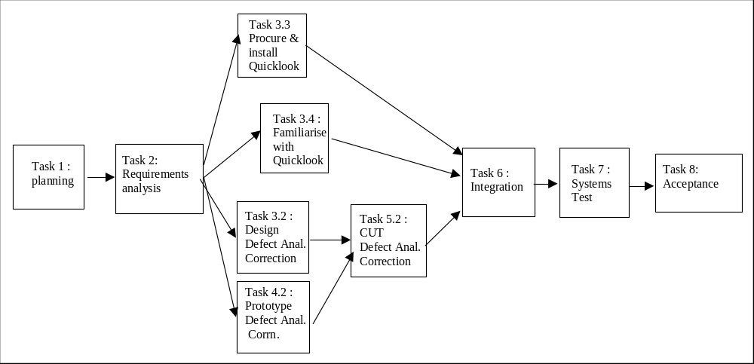Figure 4: PERT Chart for Solution (ii) -”Buy-in”

Figure 5: GANTT chart showing new plan for Quality monitoring system development

 |  | 3/3 | 3/10 | 3/17 | 3/24 | 3/31 | 4/7 | 4/14 | 4/21 | 4/28 | 5/5 | 5/12 | 5/19 | 5/26 | 6/2 | 6/9 | 6/16 | 6/23
Task 1 | Planning
Task 2 | Detailed requirements
Task 3.2 | Design of def an.al/corrn.
Task 4.2 | Prototype def anal/corrn.
Task 3.3 | Proc./install of Quicklook
Task 3.4 | Fam. with Quicklook
Task 5.2 | CUT defect anal/corrn.
Task 6 | Integration
Task 7 | Systems Test
Task 8 | Acceptance Test
Task 9 | Management
Current position of project

Key :
Completed tasks
In progress
Not yet started

